MWTGNBOP-5505
NBOP - TMO - Network Inquiry - retrieve-device(IMEI/ICCID) - UI

Step 1: Log in to NBOP application and click on Network Inquiry menu.
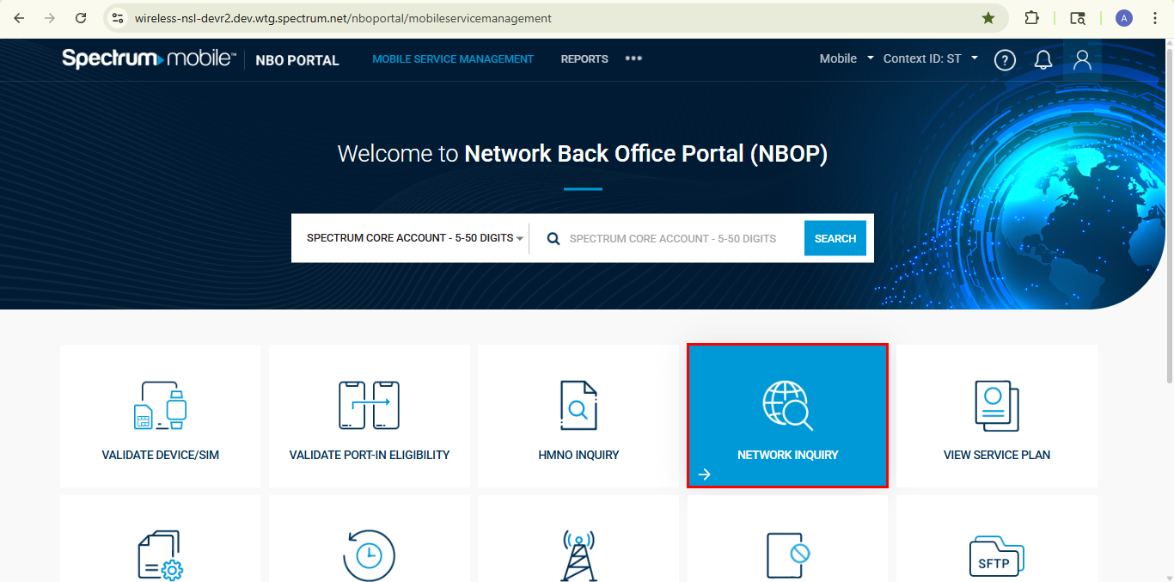
Step 2: By default, the Network Inquiry tab is selected. Ensure the MNO radio buttons are visible.
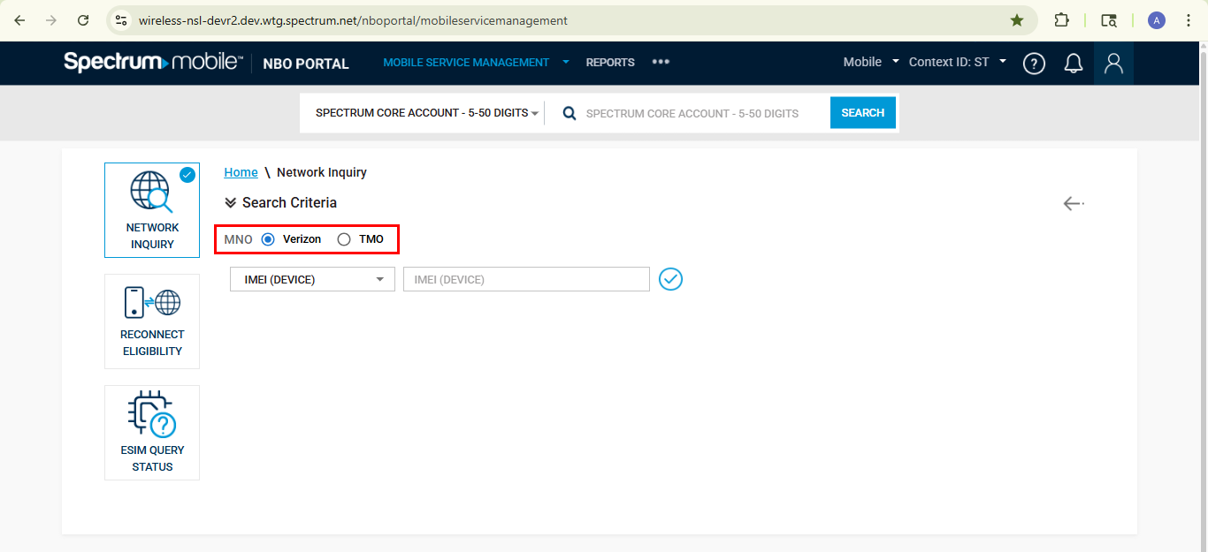
Step 3: By default, the Verizon radio button will be selected. Perform the search using IMEI/ICCID and ensure the Verizon response are populated on the Inquiry Results tab.
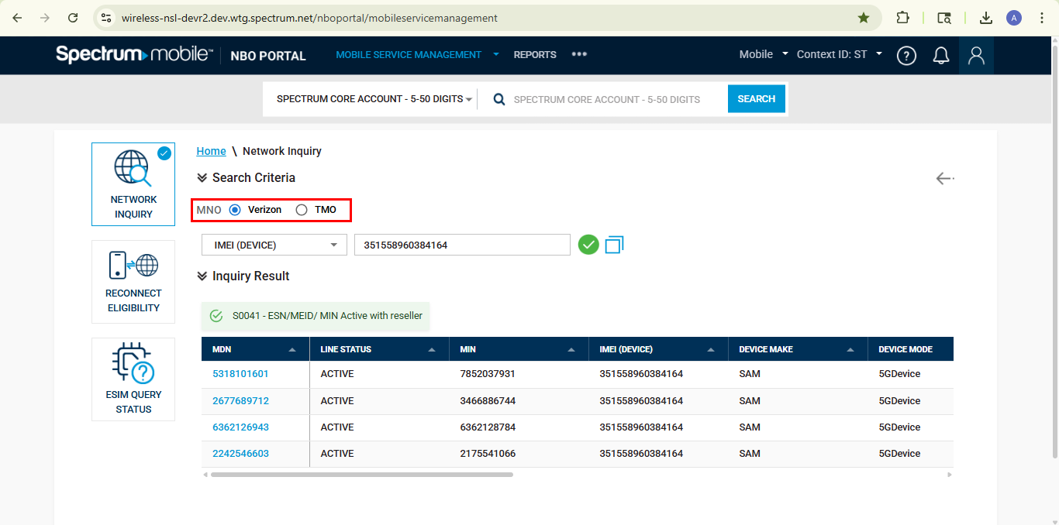

Step 4: Switch to TMO radio button and perform the search using IMEI/ICCID and ensure the TMO response are populated on the Inquiry Results tab.
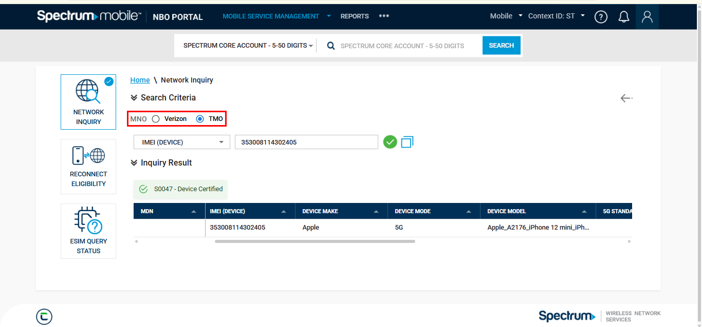

Step 5: Ensure the request type is sent as TMO in the Http Header for TMO.
